Project description
Overview
This project automates an LED strip using a PIR motion sensor, LDR and a MOSFET controlled by Arduino. The LED strip turns on only when motion is detected at dark, making it ideal for under-bed illumination at night. This project does not require programmable LED strip. Any dumb LED strip would do the job done which is what I used. The project is divided in two phases:
- Phase 1: Sensor integration, filtering and LDR-based light detection using a basic LED.
- Phase 2: Using MOSFET to drive the basic LED and then replacing the basic LED with a real LED strip.
Phase 1: Sensor Integration and Filtering
The main objective of this phase is to integrate the PIR sensor and LDR to control a basic LED based on motion and light. The logic should be right to handle false positives. HC-SR501 has 3 pins: Vcc, Dout and GND. The Dout pin sends high (3.3V) when motion is detected and low (0V) when idle. Here is how to connect the PIR sensor with Arduino:
Vcc of Arduino -> Vcc pin of PIR
GND of Arduino -> GND pin of PIR
Pin 12 -> Dout of PIR (Note: Can be connected to any available digital pin)
To connect LDR with Arduino, we create a voltage divider with because the Arduino can't directly measure resistance. It can only measure voltage through its analog pins. Here is how to connect the LDR with Arduino:
LDR one terminal -> Vcc of Arduino
LDR second terminal -> A0 pin of Arduino -> 10k ohm -> GND
Finally, connect the LED with any digital pin of Arduino. In my setup, I connected it to D8 pin of Arduino.
Note:
The main problem that I faced after the integration of PIR sensor was false triggering by tiny motions like hand waves, slight movements, etc. I solved the problem via:
1. Hardware Adjustments: The sensor’s sensitivity and time delay can be adjusted using it’s built-in potentiometers.
2. Software Adjustments: Only consider motion valid if it persists for 500ms-2s (Debounce Method) and turning on LED if PIR reads high at least 3 out of 5 times within 1 second (Consecutive Readings Method).
So you can use either of the method to solve the problem if that is what you are facing right now.
After testing the logic and it's functioning, we can move onto phase 2.
Phase 2: MOSFET AND LED STRIP INTEGRATION
The objective of this phase is to replace the basic LED with real LED strip and shift control from Arduino pin to MOSFET switching. I used a N-channel MOSFET for this project. The connections for this phase is:
+ve end of LED strip -> +ve end of 12V adapter
-ve end of LED strip -> Common Ground
-ve end of 12V adapter -> Drain of MOSFET
Source of MOSFET -> Common Ground
Gate of MOSFET -> 330 ohm resistor and D8 pin of Arduino (D8 pin was originally connected to the basic LED)
Note: A 10kΩ pull-down resistor is connected between the Gate and Ground to prevent floating gate voltage when the Arduino is OFF or during boot-up.
To turn on the MOSFET, we need to apply threshold voltage between gate and source (2-4 V for my MOSFET). When no motion is detected, the D8 pin of Arduino outputs low voltage (0V since D8 pin in my arduino is not PWM) and the MOSFET remains off. As there is no closed path for the led strip, it remains off. When motion is detected, the gate terminal becomes high (5V), essentially turning on the MOSFET and creating a closed path for the LED strip. This turns on the strip. This is the whole idea of the project.
After the completion of both phases, the entire project can be transferred to perf board for final deployment.
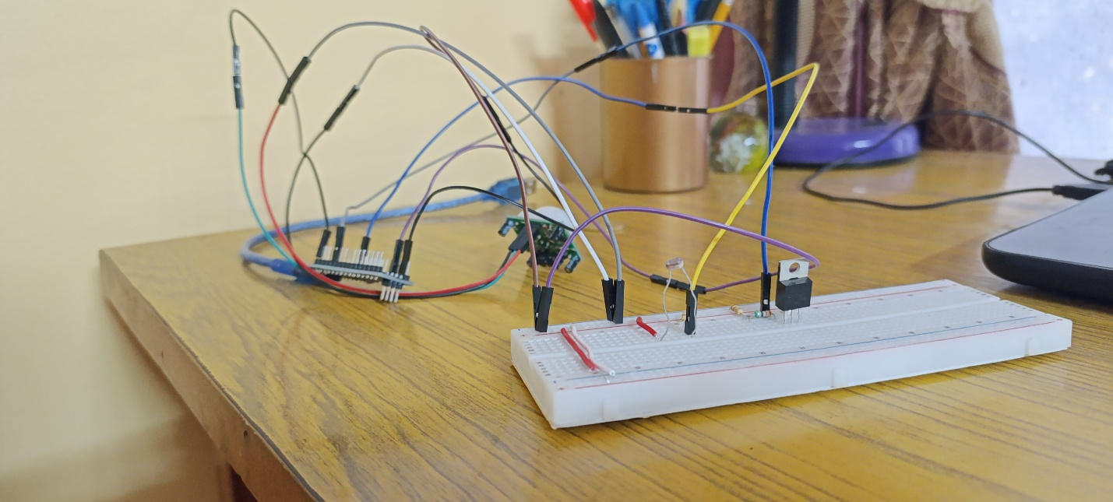
Integration in breadboard
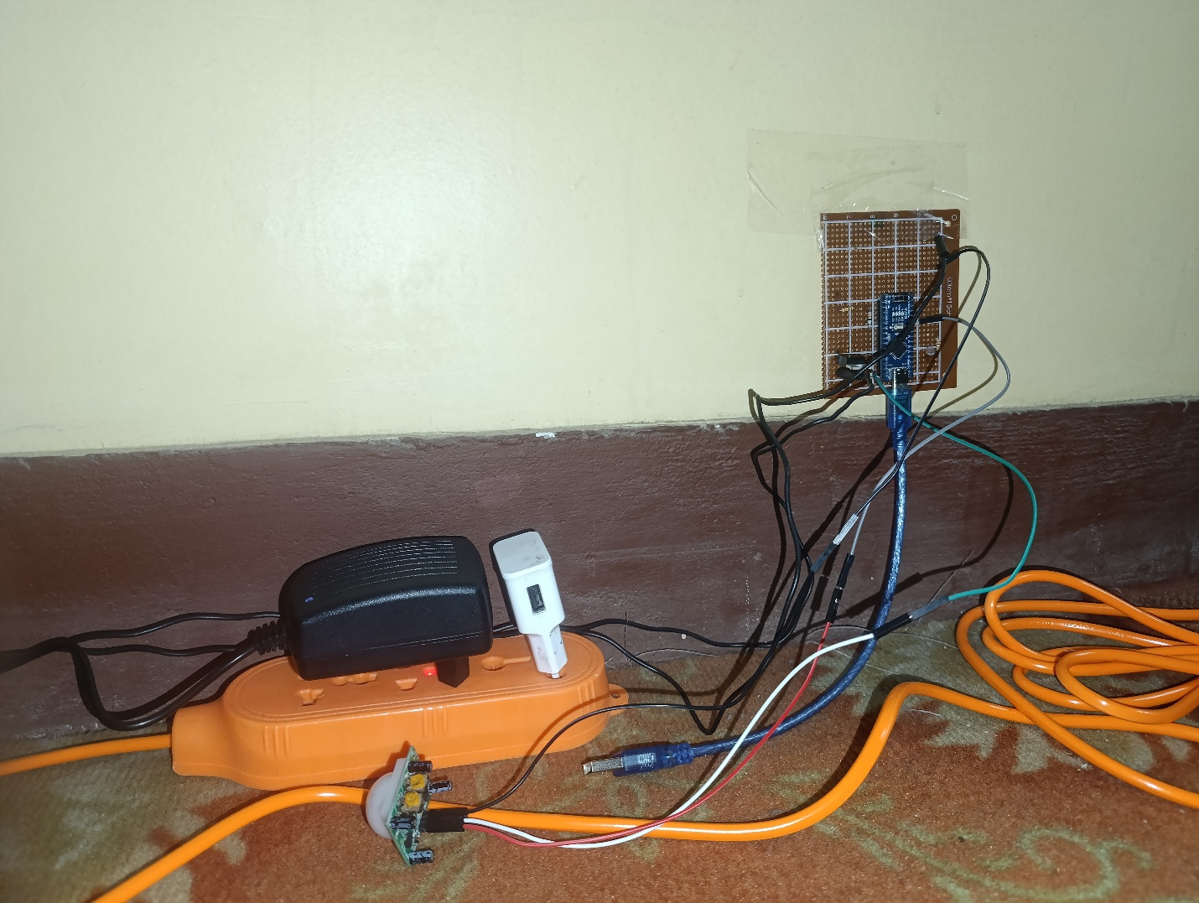
Final integration in perfboard

